Step 1: Advanced Encryption Package 2017 - Downloaded and Installed from <http://www.aeppro.com/download/latest.shtml>

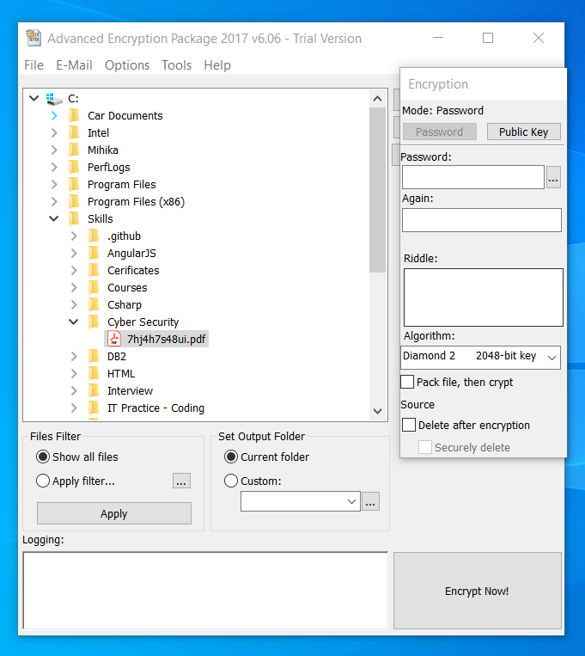

Step 2: Select file to be encrypt -> Enter Password -> Select Algorithm -> check options in source (Delete after encryption and secure delete)

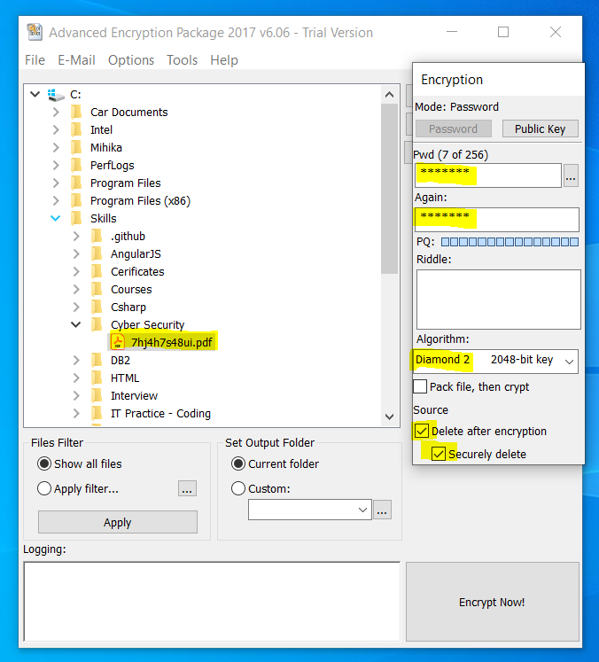

Step 3: Click Encrypt Now!

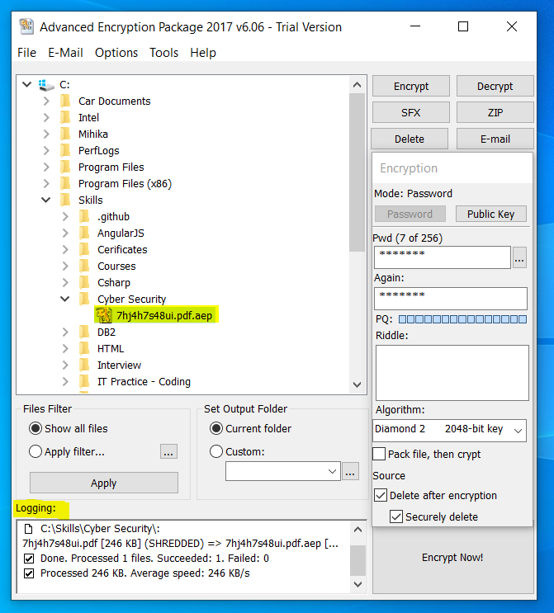

Step 4: File is successfully encrypted.

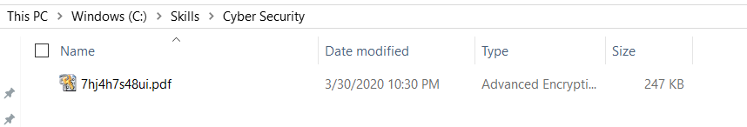

Step 5: File Decryption: Enter Password

